Module 1 Discussion

Using the 100 Things Every Designer Should Know About People reading assignment, select two (2) of the "things" you read about, include the number and title of the "thing" (i.e., #36 Time is Relative) , and then do two embellishments, one embellishment and one visual example, or two visual examples.
- Embellish: Tell us something that the reading did not tell us on that specific "thing" or embellish on what was presented. Be sure you are adding meaningful content to the conversation and not just making noise. Your addition can be a link to an article, or you can write out your embellishment.
- Visual Example: Provide us with a graphic example that is relevant to web design. This can be something you create or something you find. Again, be sure to add meaningful content to the conversation.

Topic #4: There’s a Special Part of the Brain Just for Recognizing Faces
Embellishment:
What I’m going to talk about here is a little bit personal, but it applies to a vast array of these topics that I’ve read so far in this book. This topic stood out to me because it specifically called out how Autistic people don’t use this part of their brain. I have an autistic child, which revealed to me that I also am Autistic (and I do have a diagnosis, it is not self-diagnosed). The autistic brain works differently in a vast array of ways, and it is different for each autistic person, but (generally) autistic people cannot pick up on social and subtle cues that most people can. Part of recognizing faces is recognizing the emotion on the face, and this is where the topic at hand comes in. During my management training at Kwik Star, we were required to take a test to assess our ability to identify emotions based on a person’s face, with the eyes covered. From personal experience, I am not skilled at reading a person’s emotions in real-time, but I excelled at this test. The reason is that I have developed a sort of internal database (“frown = sad” or “scowl = angry”). In real-time, it’s harder to pick up on these variations. Still, in images meant to resemble them, I scored near-perfectly because they match the image in my head of what the emotion is supposed to look like, even though in a real-life scenario, I would score poorly.
The reason I discuss this is that images need to convey something. In the example in this topic of the book, the woman is looking at a product and looks happy. It needs to be a generic, easy-to-tell happy look for everyone to pick up on. If she seems a little confused, or worse, angry, it will confuse many people about the purpose of the advertisement (unless they’re trying to turn you off to a product).
Visual Example:
My visual example for this comes from the political arena. The emotion conveyed by the faces we see affects how we feel about something. When a candidate places an ad, they want to represent themselves as a strong leader. And a positive, people-oriented person, so they will put images of themselves with people and leading, or taking a stand:

Credit: John Gurzinski/Getty Images
On the other hand, when someone wants to paint the person in a negative light, you can put an image of them showing them depressed, disappointed, looking down, angry, or other “negative” emotions, as shown below:

Credit: Nicholas Kamm/AFP/Getty Images

These cues subconsciously inform us about what we should be thinking regarding the person or message we are hearing. There are factors to consider when designing a webpage with images of people on it, as they can significantly impact the page's effectiveness.

Topic #7: People See Cues That Tell them what to do with an Object
Embellishment:
One aspect closely related to this is the use of icons. Icons represent things that are easy to understand without the need for text. For example, A small image of a pentagon with a rectangle in it (a house) is a “home” button, and if you put it somewhere, any pretty much any user will automatically look at it and think that it will take them to a homepage or root drive or something else that is a base location. Some of these are intuitive, others are learned, and some depend on context. For example, in a word processor, an icon that resembles the letter “A” will prompt most of us to think that it is where we can adjust the font. If you deviate from that norm or use an icon for something that is commonly associated with something else (for example, using the “A” icon for an administration tab), you will confuse many users.
Visual Example:
For a visual representation, I give you the 3D-printed save button!
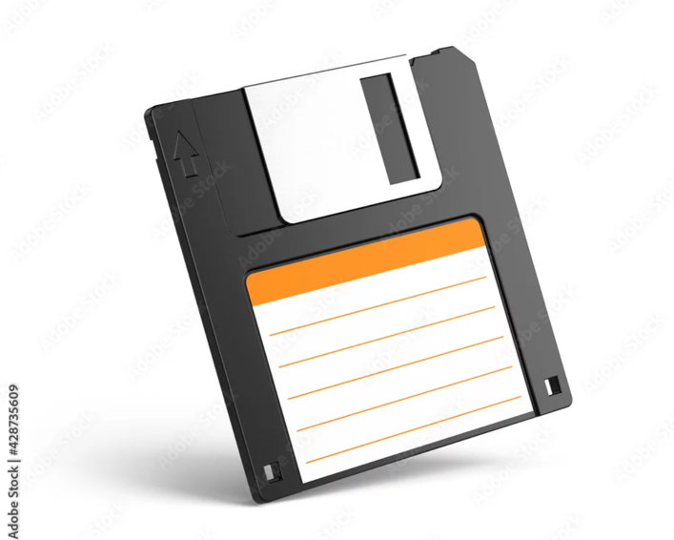
Credit: Adobe Stock Photos
There’s a story I read on the internet once about the kid who found a floppy disk and brought it to his father and said, “Dad! You 3D-printed a save button!” Generational gap humor aside, the point is, the child had never seen or known what a floppy disk was, but knew what it was because it is the standard image for a save icon. This is because we used to save things on these 1.5 MB external storage devices (and who would ever need more than this? Entire Operating systems would fit on one of these!)
If the save icon were to be created today, it would likely resemble a USB Thumb Drive. So why hasn’t it changed? Because everyone knows that’s a save button, and even though the original meaning is lost (much like happens with language), it’s still ingrained within us that this is a save icon.

